DEPARTMENT OF
ELECTRONIC COMMUNICATIONS
DEPUTY MINISTRY OF RESEARCH, INNOVATION AND DIGITAL POLICY

Public Consultation for Broadband Connectivity
Voucher Scheme
(Investment under Recovery and Resilience Facility)

11 March 2022
Voucher scheme to promote connectivity take-up
Public consultation pursuant to paragraphs 64 and 78 (b) of the European Union Guidelines for the Application of State Aid Rules in relation to the Rapid Development of Broadband Networks
Preliminary remarks
1. The Cypriot Recovery and Resilience Plan, adopted by the European Council in July 2021, under Component 4.1, foresees dedicated investments to promote connectivity take-up.
2. This investment aims to encourage connection of end-users to Gigabit capable networks, deployed close to their residence, through the reduction of set-up costs and subscription fees. For the implementation of the measure, a demand side voucher scheme will be set-up to support the costs of connection of households, as well as the first 12 months of subscription. The direct beneficiaries and end users of the scheme are households in selected areas of Cyprus. The total budget allocated to the scheme will be of 10,000,000 EUR, expected to benefit approximately 82,000 households. The intervention scheme will run from 2022 to 2025.
3. This document outlines the main features of the voucher scheme. It is submitted for public consultation by the Department of Electronic Communications, in line with European State aid rules, pursuant to paragraphs 64 and 78 (b) of the European Union Guidelines for the Application of State Aid Rules in relation to the Rapid Development of Broadband Networks. All interested stakeholders are invited to submit their comments and observations by 12th of April 2022 at the following e-mail address: nioannou@dec.dmrid.gov.cy
4. Following the outcome of the public consultation, the voucher scheme will be notified to the European Commission pursuant to Article 108, paragraph 3 of the TFEU.
High-level project description
Objectives of the scheme:
5. The project aims to support households in getting Gigabit connections, through the reduction of the setup costs and a subsidy to cover the first 12 months of subscription.
Target population and intervention areas:
6. The aid will be accessible to all households which do not yet have connections up-gradable to 1 Gbps download speed located within the intervention area. The intervention area will be defined by where fiber or equivalent deployment is possible. The exact intervention areas will be reviewed on an bi-annual basis (see below). Both Multi-dwelling units (MDU) and single dwelling units (SDU) will be eligible. It is expected that approximately 82,000 households will benefit from the vouchers.
7. Vouchers can be used for subscriptions to services of any operators able to reliably provide the speeds of 1 Gbps download and 250 Mbps upload over an existing broadband network, irrespective of the technologies used.

Eligible intervention areas:
Existing coverage for eligible intervention
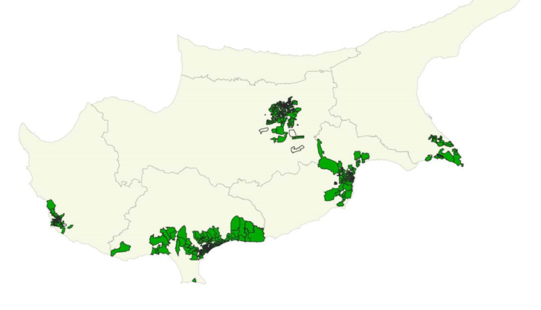
8. The map will be up-dated on a bi-annual basis in consultation with the telecommunications operators. New areas will be added as the infrastructure to provide 1 Gigabit connections in Cyprus grows.
Eligible costs:
9. The voucher will support the cost of connecting the household as well as the 12 first months of subscription. The connection to be offered must be of at least 200 Mbps download, up-gradable within three working days to a 1Gbps download and 250 Mbps upload speed connection. The voucher will be limited to maximum 50% of the eligible costs.
The aid amount:
10. Each eligible household can apply for a voucher. The voucher will be of a fixed value of Euro 120. The objective of this single amount is to make the application process and management process as simple as possible. The individual challenges or difficulties in connecting specific buildings or apartments will not be taken into account. All beneficiaries will receive the same amount.
Scheme budget and duration:
11. The total budget of the scheme will be of 10,000,000 EUR for the period 2022-2025.
The application process:
12. In order to benefit from the aid, the following process will be observed:
a) Households in eligible areas can contact an operator to provide the connection and subscription
b) The operator ensures through a self-declaration form from the household that no prior Gigabit capable connection exists.
c) The operators make the required installation / connection.
d) A speed test proving that the required speed is delivered at the recipient’s premises has to be made, and counter signed by the household and the operator. This speed test has to take place at the end point. This step ensures that speeds are not just achieved at the connection point of the building, but actually at the flat / apartment within the building.
e) Based on the proof of delivery and the self-declaration the operators can, on a six-monthly basis, redeem the vouchers against payment through the dedicated DEC portal.
13. This means that the households will not as such receive any funds. The voucher scheme allows the households to get a connection and very high speed subscription at reduced price.
14. The household is free to choose the operator.
15. By accessing the voucher, the beneficiary household agrees not to terminate the service contract concluded with the operator before the 12-month subsidized subscription period.
16. Through the self-declaration the household confirms that no prior Gigabit capable connection, is currently available at the premises. A false declaration can lead to sanctions and reimbursement of the voucher amount.
Network access:
17. Where an operator is vertically integrated and has a retail market share above 25%, in order to be included in the voucher scheme, that provider must offer, on the corresponding wholesale access market, to any electronic communication services providers at least one wholesale access product able to ensure that the access-seeker will be able to reliably provide the eligible services, under open, transparent and non-discriminatory conditions. The wholesale service price for the respective product must be less than or equal to the regulated wholesale prices approved by the Cypriot National Regulatory Authority (NRA), as applicable or can be determined through any existing commercial agreements.
18. It must be noted that in the case of buildings with more than 8 units / households any cabling must also be shared by any operator active in the building according to the provisions of the In-House Wiring Infrastructure Order (352/2015) as amended. It is also possible to share cabling in the case of buildings with less than 8 units in cases where it is not feasible for others to deploy their own fiber infrastructure. According to this Order, the first operator that deploys optical infrastructure is obliged to provide access to the other operators at the optical fiber terminal part that connects the network termination point to the optical socket inside the premises. This will allow residents to select from any operator regardless of which installed the cabling originally.
Checks and audits
19. The Government of Cyprus, notably DEC and the Audit Office of Cyprus will be entitled to carry out spot checks to verify the correct implementation of the voucher scheme.
20. As such, upon request, any household applying for a voucher will have to give access for the carrying out of speed checks of the new installation, as well as making available the subscription contracts prior and after the receipt of the voucher scheme.
21. By participating in the voucher scheme, the operators agree that audits be carried out at their premises. This should notably allow the authorities to establish that claimed vouchers were implemented according to the specification of the scheme.
Jurisdiction:
22. Any party may contact the Department of Electronic Communications regarding issues in the implementation of the voucher scheme.
23. Any dispute or claim regarding the implementation of the scheme shall be subject to the jurisdiction of the competent Cypriot courts.
24. All interested stakeholders are invited to submit their comments (Greek or English) on the voucher scheme described above by Tuesday 12th of April 2022 at the following e-mail addresses: akakkouras@dec.dmrid.gov.cy, nioannou@dec.dmrid.gov.cy. In their answers, stakeholders are encouraged to address in particular but not limited to the following topics:
- Are there any areas in which operators could provide 1Gbps download speeds which are not reflected on the intervention area map? If so, which? Please provide any pertinent information on the existing or planned network which affects the areas in which the voucher scheme can be applied.
- Which technologies will be used to provide 1 Gbps download and 250 Mbps upload speeds?
- Is the certification / acceptance process clear? The objective is to ensure that the speeds are delivered not at the connection point to the building, but at the usage point within the building, notably for multi-dwelling units
- Could you provide information supporting the existence of a market failure?
- What is the average set-up cost and the necessary terminal equipment cost per household?
- What is the average cost of 12 months subscription for the required speeds?

25. Pursuant to the provisions of the Broadband guidelines, the Government will publish the main characteristics of the measure and the list of target areas identified in the mapping exercise amongst other on an appropriate publicly available webpage at national level https://dec.dmrid.gov.cy.

